Title: Cyclonus：A social robot for practicing pingpang skills of pingpang fans

**Name**: Jianyu Zhou

**Student Number**: 1769730

**Introduction**

There are tons of pingpang fans in China with great enthusiasm in pingpang. But due to the difficulty of finding a good player as well as their suitable time for playing, there is a huge demand for people to practice their pingpang skills at a more flexible time. Our pingpang robot, Cyclonus, is designed for the solution of meeting this demand. With Cyclonus, you don’t have to take hard efforts to find a good coach or manage your playing time considering your friends’ spare time, and are able to enjoy the pingpang playing with professional instructions.

**Robot design**

The robot at current stage are designed in two portions. First is the robot face, and the other is the interactive dialog. For robot face, we design a simple but lovely face with svg elements. The face basically contains a square as face outline, two blue circles as eyes, a red bar as mouth and a glass-like outline as eyeglasses. A picture of the face is shown in Fig.1. Additionally, our robot face is not just a static svg, but also change features with user ‘s mouse interaction. The facial expression will change dynamically with some mood-related message shown in the dialog as user click on the robot’s face. Details are shown in Fig.2. As an additional function, we make the robot look towards the cursor when mouse is hovered on robot’s face, as shown in Fig.3. Last, to make our robot looks more vivid, we make the robot eyes blink naturally, which will blink every 3.5s.

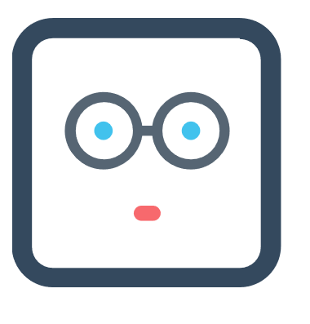

Fig.1. Robot Face

For the interaction part, we use a svg to draw a speech bubble with texts displayed in it. The main components of this part are user input box and the robot speech bubble. Once you click the “Test your pingpang level” button, the robot will ask two questions: your sex and your pingpang score, which is given by CNTTR. The detailed criteria can be seen in Table.1. and Table.2. Based on your answers, the robot will respond with an assessment of your pingpang level. Please pay attention that If your input doesn’t meet the requirement of the question, for example, you answer “haha” as a respond to “what’s your sex?”, the robot will remind you of your fault and ask you to answer it again, as shown in Fig.4.

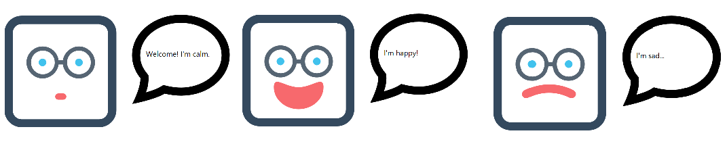

Fig.2. Facial expression: calm, happy and sad.

Table.1. Pingpang level assessment by man

|  |  |
| --- | --- |
| Score range | Assessment |
| 0-1000 | Novice |
| 1000-2000 | Good amateur player |
| 2000-3000 | Good professional player |
| >3000 | Top-class player |

Table.2. Pingpang level assessment by woman

|  |  |
| --- | --- |
| Score range | Assessment |
| 0-800 | Novice |
| 800-1500 | Good amateur player |
| 1500-2500 | Good professional player |
| >2500 | Top-class player |

**Robot functionalities**

We implement all functions that mentioned in the assignment page, these include:

* Robot eyes are able to look in different directions.
* Robot is able to look towards the cursor when it’s hovered on the robot’s face.
* Robot contains a speech bubble to display texts.
* Robot has two additional facial expressions in addition to its neural expression.
* Robot eyes are able to blink naturally.
* Robot’s facial expression can be changed and display a different text in speech bubble when mouse is clicked on its face.
* Robot is able to interact with user with asking questions to user and give various response based on user’s various answers.
* Two pages on combined into one so that the communication between the two pages can be easily tested.
* Robot is able to handle some accidental interaction like receiving undesirable answers from user.

**Implementation**

* We use bootstrap framework as our html and css library as to make our work easier and more scalable.
* We use jquery which is a popular javascript library to help element manipulation.
* We use svg to create robot face and speech bubble.
* Assignment link: https://codepen.io/peigon/full/XeOmBj/

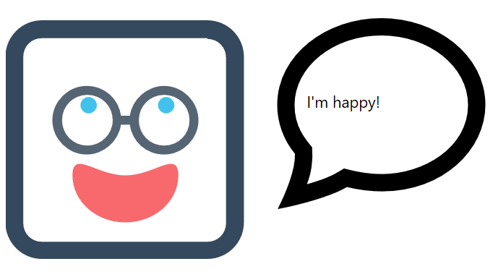

Fig.3. Robot looks towards the cursor

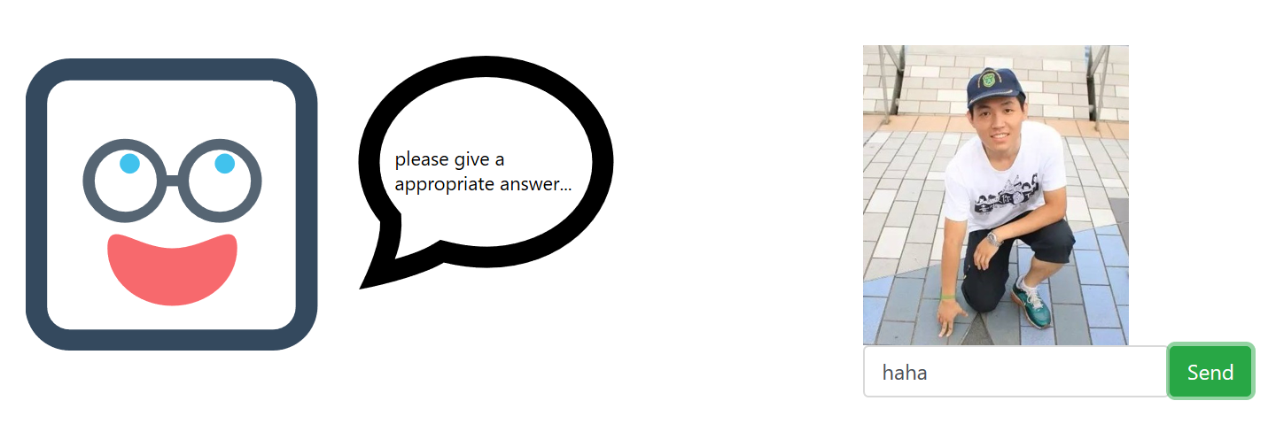

Fig.4. An example of dialog

**Difficulties**

* How to redraw eyes dynamically based on the location of cursor hovered on the robot face.
* How to upload and reference a local picture to a webserver, in this case we use github.
* How to draw and manipulate the svg element—svg online editor.
* How to properly display elements—bootstrap grid system.
* How to make the robot’s eyes blink—set time interval of action of opening and closing eyes.